





Weekly Newsletter
Mrs. Reece’s
September 15, 2017

Reading- *Theme- Friendship
*Story- Huggapotomus
*Beginning Sounds of words

Writing- * Learning writer’s workshop routines
* Getting writing ideas/
brainstorming

Math-Sorting and Patterns
* This is a great time to let your
kids sort laundry or buttons at
home!

Leader in Me Habit- Proactive

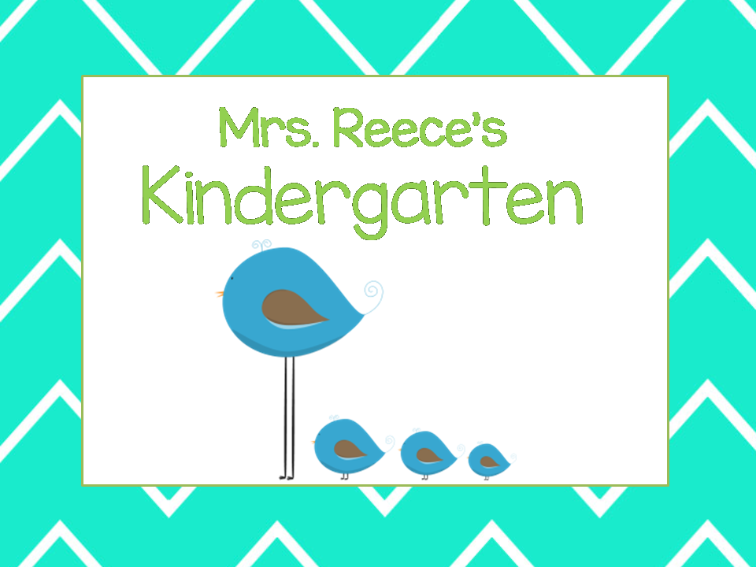

Technology
-I try to use technology to keep parents informed and convenient ways to communicate.
-Sign up for Remind

- Your child is encouraged to bring a water bottle.
-We are still collecting snack donations. We appreciate every family’s contribution..

Sep. 22- No School
Sep 26- Incredible Indian Pow-Wow
Oct. 3- Tell Me a Story Night
Oct 10- Field Trip

Reminders
Upcoming Events
- Text my class code @9h966h to 81010.
- Reply to the message from the Remind team with your first and last name, and you're in!

